**Link to a GitHub user account**

1. Log in to Docker Hub using your Docker ID.
2. Click **Account Settings** in the top-right dropdown navigation, then open **Linked Accounts**.
3. Click **Connect** for the source provider you want to link.

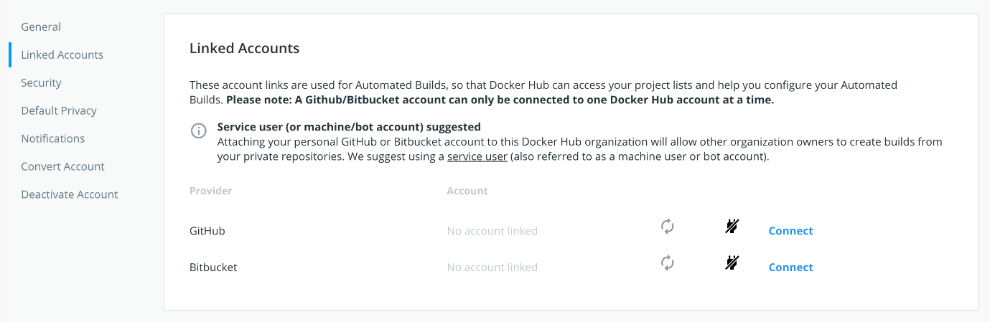

1. Review the settings for the **Docker Hub Builder** OAuth application.

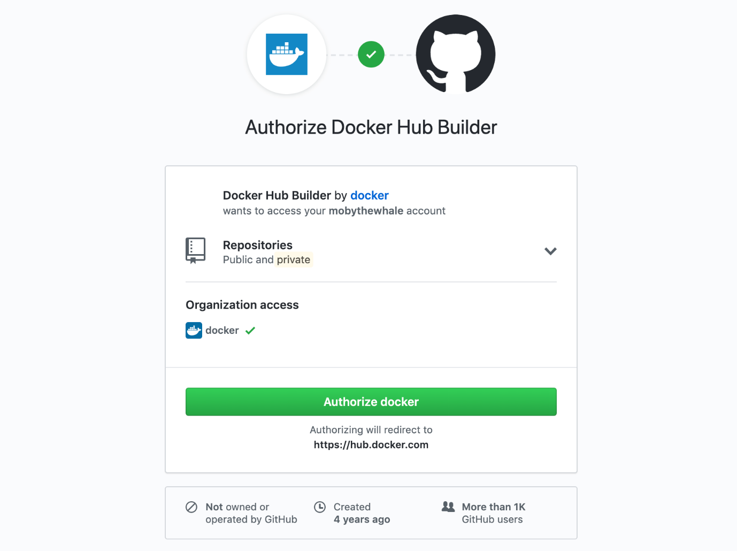

**Note**: If you are the owner of any GitHub organizations, you might see options to grant Docker Hub access to them from this screen. You can also individually edit an organization’s third-party access settings to grant or revoke Docker Hub’s access. See [Grant access to a GitHub organization](https://docs.docker.com/docker-hub/builds/link-source/#grant-access-to-a-github-organization) to learn more.

1. Click **Authorize docker** to save the link.